LOW-CODE EXPERIMENT
Gym Membership Reports Suite
Setting Up the Zoho Creator Application and Exploring Platform Architecture

Roshan S
241501170
AIML

Rajalakshmi Engineering College
Academic Lab Record

Abstract
This experiment documents the setup and exploration of a Zoho Creator application for the Gym Membership Reports Suite. The application is based on the existing Membership_Enrollment_Form used to capture gym member details. The experiment explains how the application is organized, how reports provide different views of membership information, and how the platform's forms, reports, pages, workflows, Deluge scripting, integrations, and deployment environments fit together. Project-specific interface illustrations are included to show how the gym application and its reports can be organized.

1. Aim
To configure and explore the Zoho Creator application for the Gym Membership Reports Suite and understand how its platform interface and architecture support the creation of nine purpose-built reports from Membership_Enrollment_Form.

2. Introduction
Zoho Creator is a cloud-based low-code application platform that allows users to build business applications using visual tools. Forms collect data, reports present records in different formats, and workflows automate actions. For the Gym Membership Reports Suite, the base form captures member enrollment details, while reports help the gym owner, front-desk staff, and trainers review and act on membership data. The nine report types covered are List View, Spreadsheet View, Kanban View, Calendar View, Map View, Timeline View, Pivot Table, Chart View, and Summary View.

3. Requirements
- A computer with an internet connection and a modern web browser.
- A Zoho account with access to Zoho Creator.
- An existing Zoho Creator application containing Membership_Enrollment_Form.
- Sample membership records with suitable values for plan, membership type, fee status, preferred start date, address, and assigned trainer.

4. Procedure

Step 1: Sign in and open the gym application
Open Zoho Creator and sign in with the account used for the project. From the home screen, open the application named Gym Membership Enrollment & Front Desk Management (or the existing application that contains Membership_Enrollment_Form). Check the application navigation and confirm that the membership form and report-building options are available.
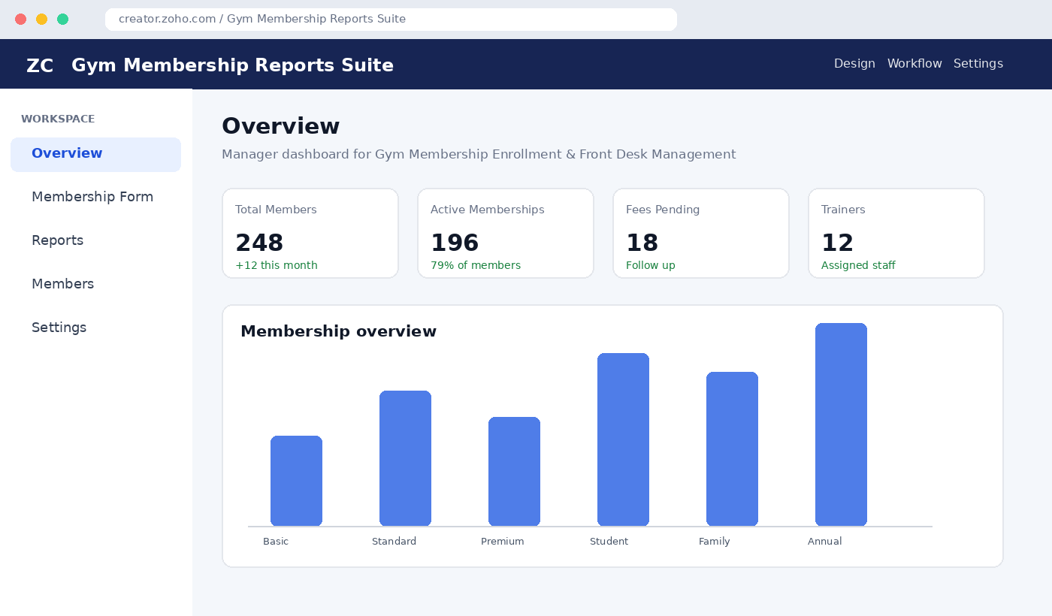
Figure 1: Project-specific illustrative dashboard for the Gym Membership Reports Suite (mockup, not a captured Zoho screen).

Step 2: Confirm the base form and application structure
Open Membership_Enrollment_Form and review the fields already configured in the project. The report suite depends on fields such as Member Name, Contact Number, Membership Plan, Membership Type, Fee Paid Status, Attendance Today, Renewal Due Date, Status, Preferred_Start_Date, Residential_Address, Enrollment_Submitted_On, and Assigned_Trainer_Lookup. Use the exact field names present in the existing application when configuring reports.

Step 3: Create the reports from the base form
In the application builder, create each report using Membership_Enrollment_Form as its source. Select the appropriate report type, set the report name, choose the displayed fields, and configure sorting, grouping, filters, and summaries according to the use case. Save each report and test it with sample records.
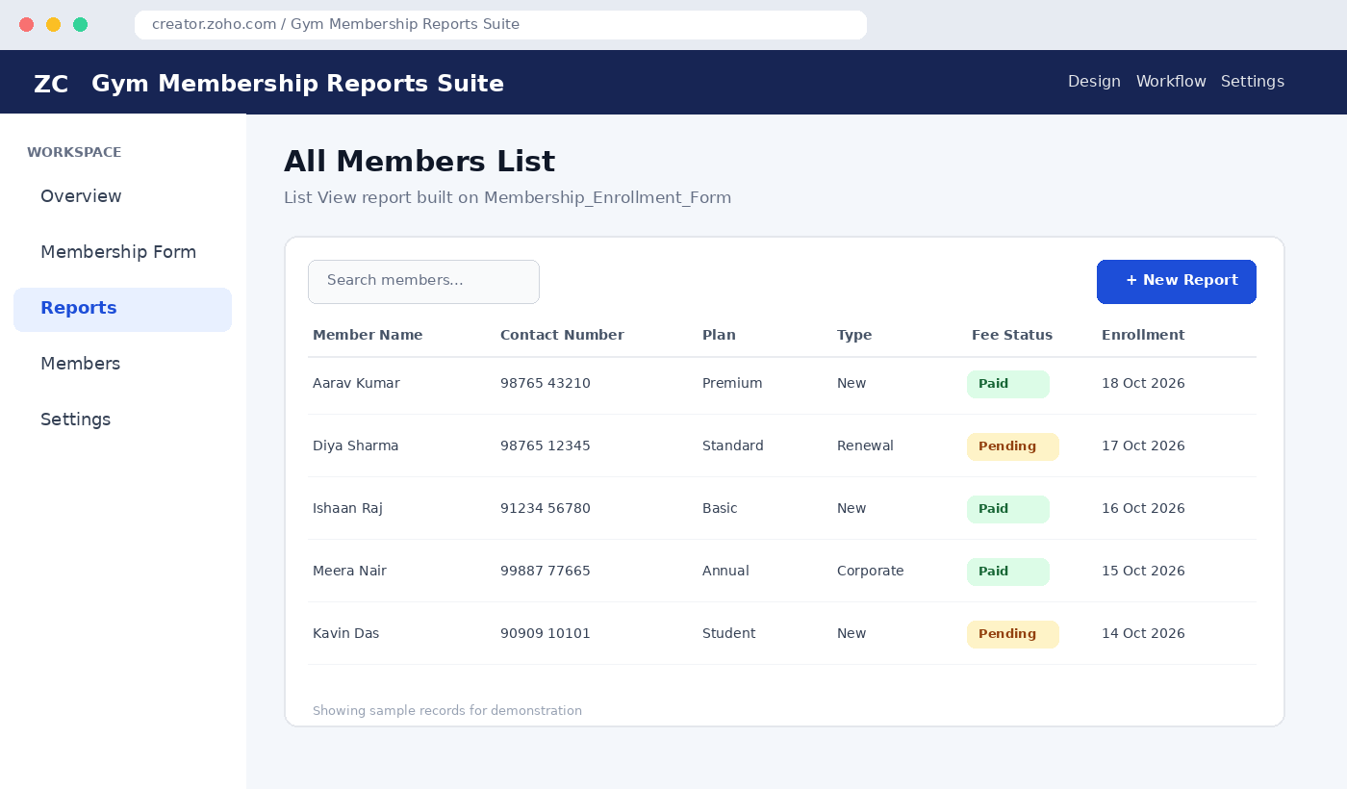
Figure 2: Illustrative All_Members_List report layout showing gym membership records (sample data).

Step 4: Configure the nine report types
Report Type | Report Name | Purpose | Key Configuration
List View | All_Members_List | Browse and search all members | Member, contact, plan, type, fee status; newest enrollment first
Spreadsheet View | Members_Spreadsheet | Bulk-update daily operational fields | Attendance Today, Fee Paid Status, Renewal Due Date; group by plan
Kanban View | Membership_Status_Kanban | Track membership lifecycle visually | Group by Status: Enquiry, Enrolled, Active, Expired
Calendar View | Membership_Start_Calendar | Plan upcoming member starts and induction | Use Preferred_Start_Date
Map View | Member_Residential_Map | Understand residential distribution | Use geocoded Residential_Address; distinguish plans if supported
Timeline View | Enrollment_Activity_Timeline | Review enrollment momentum | Use Enrollment_Submitted_On; group by week
Pivot Table | Plan_By_MembershipType_Pivot | Compare plan and membership-type mix | Rows: Membership_Plan; columns: Membership_Type; value: member count
Chart View | Plan_Popularity_Chart | Compare popularity of plans | Bar chart; X-axis: Membership_Plan; Y-axis: member count
Summary View | Trainer_Wise_Summary | Review trainer workload | Group by Assigned_Trainer_Lookup; count members; include Unassigned
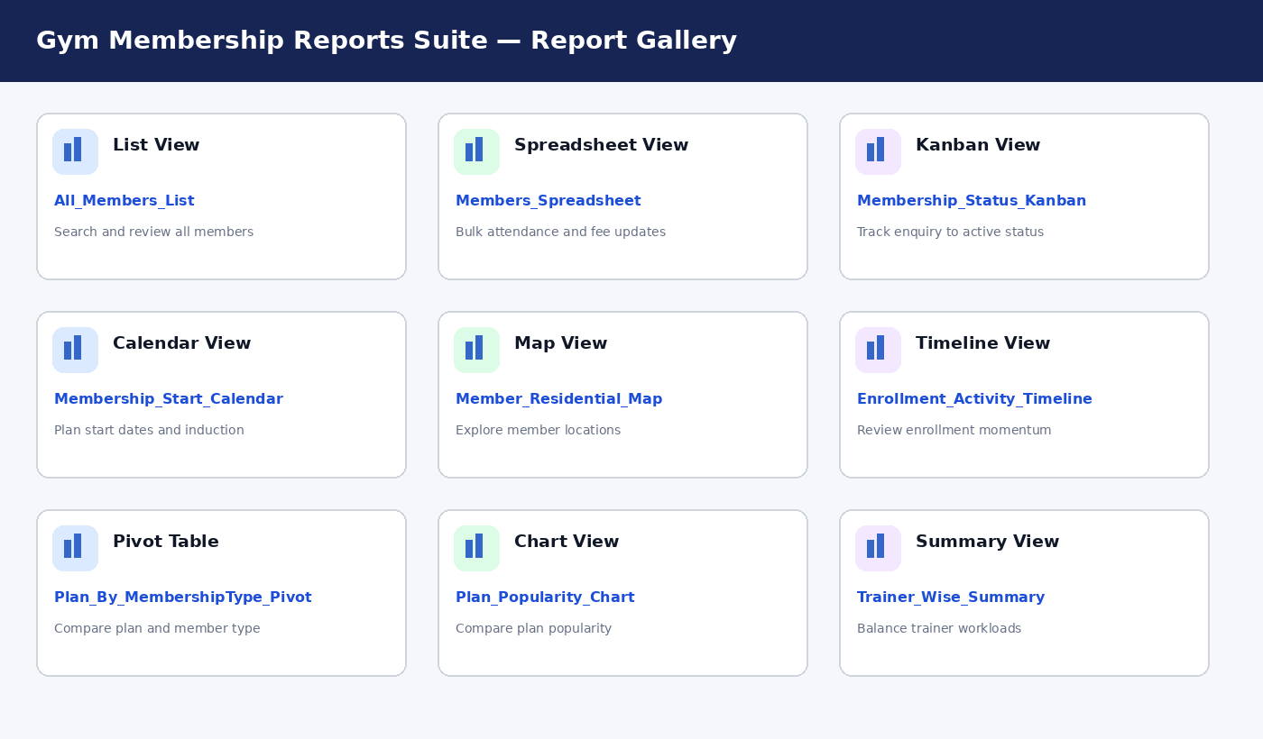
Figure 3: Illustrative gallery of the nine reports included in the Gym Membership Reports Suite.

Step 5: Validate report behavior and access
- Set All_Members_List to sort by Enrollment_Submitted_On in descending order.
- Restrict inline editing in Members_Spreadsheet to the front-desk role and only the operational fields intended for editing.
- Check that Kanban status changes update the underlying Status field; add a timestamp workflow if required and supported by the application.
- Confirm Calendar View uses Preferred_Start_Date and that clicking a date opens the relevant records.
- Enable or verify geocoding for Residential_Address before relying on Map View pins.
- Check weekly grouping and refresh behavior for Enrollment_Activity_Timeline.
- Configure blank pivot values to display as zero if that option is available.
- Confirm Plan_Popularity_Chart refreshes when new enrollment records are added.
- Ensure members without a trainer appear under Unassigned in Trainer_Wise_Summary.

5. Platform Architecture
The Gym Membership Reports Suite follows a layered application structure. Users access the application through the browser or supported mobile/portal interfaces. The presentation layer contains the enrollment form, reports, pages, and dashboards. The logic layer contains workflows, Deluge scripts, schedules, and approvals. The data layer stores membership records managed by Zoho Creator. Connections and APIs can link the application with other services. Environments support controlled movement from Development to Stage and Production.

Figure 4: Layered Zoho Creator architecture mapped to the Gym Membership Reports Suite (conceptual diagram).

6. Interface Exploration
Interface Area | Items to Explore | Purpose in This Project
Application navigation | Membership form, reports, pages, settings | Open the base form and report suite
Design / Report Builder | Report type selector, fields, sorting, grouping | Configure the nine report types
Workflow | Form actions, field updates, notifications | Automate status timestamps or operational alerts where required
Access controls | Users, roles, permissions | Separate front-desk, trainer, and manager capabilities
Environments | Development, Stage, Production | Test changes before publishing
Report interaction | Search, filters, calendar drill-down, Kanban movement | Validate reports using sample records

7. Observations
- A single base form can support multiple reports, each designed for a different operational question.
- List and Spreadsheet Views support routine record review and updates, while Kanban and Calendar Views make status and scheduling easier to interpret.
- Map and Timeline Views provide geographic and time-based perspectives when the required address and date fields contain usable data.
- Pivot, Chart, and Summary Views help the manager compare membership plans, identify trends, and review trainer workload.
- Permissions and field availability should be tested in the actual Zoho Creator application; the interface figures in this report are illustrative mockups.

8. Result
The Zoho Creator application structure and report configuration plan for the Gym Membership Reports Suite were documented. The nine report types were mapped to Membership_Enrollment_Form, and the relevant architecture, validation rules, and stakeholder uses were identified.

9. Conclusion
Zoho Creator provides a flexible low-code environment for transforming membership enrollment records into operational reports and management insights. Using nine report types enables the gym owner, front desk, and trainers to view the same underlying membership data in formats suited to their tasks. The report suite should be validated with real sample records and the actual permissions available in the application before submission.

10. Summary
This experiment adapts the setup-and-platform-architecture lab-record format to the Gym Membership Reports Suite. It describes the base form, the report creation procedure, the purpose and configuration of all nine report types, platform layers, interface areas, and validation checks.

11. Learning Outcome
After completing this experiment, the student should be able to explain the structure of a Zoho Creator application, create purpose-built reports from a common form, configure sorting/grouping/summary options, validate report interactions, and relate platform architecture to a real-world gym management use case.

Note on screenshots
The figures in this document are project-specific illustrative mockups created to represent relevant screens and architecture. They are not genuine screenshots captured from a live Zoho Creator account. For a final evidence-based lab submission, replace or supplement them with screenshots from your own application showing the nine reports in their configured states, the report type selector, and at least one interaction such as a calendar drill-down or Kanban status change.

